Web Programming

Laboratory Weekly Report

Week 3

**Project – Library Management System**

Aim: To design a functional library management system

Techniques Used: HTML, PHP

Procedure

1. edit_book.php: This page is used to show the various details of a book. The page can be accessed by both the librarian and the user.

The details shown to the user are:

* 1. The name of the book
  2. The author of the book
  3. The description of the book
  4. The total number of copies of the book available in the library
  5. The number of copies left
  6. The video url
  7. The image url

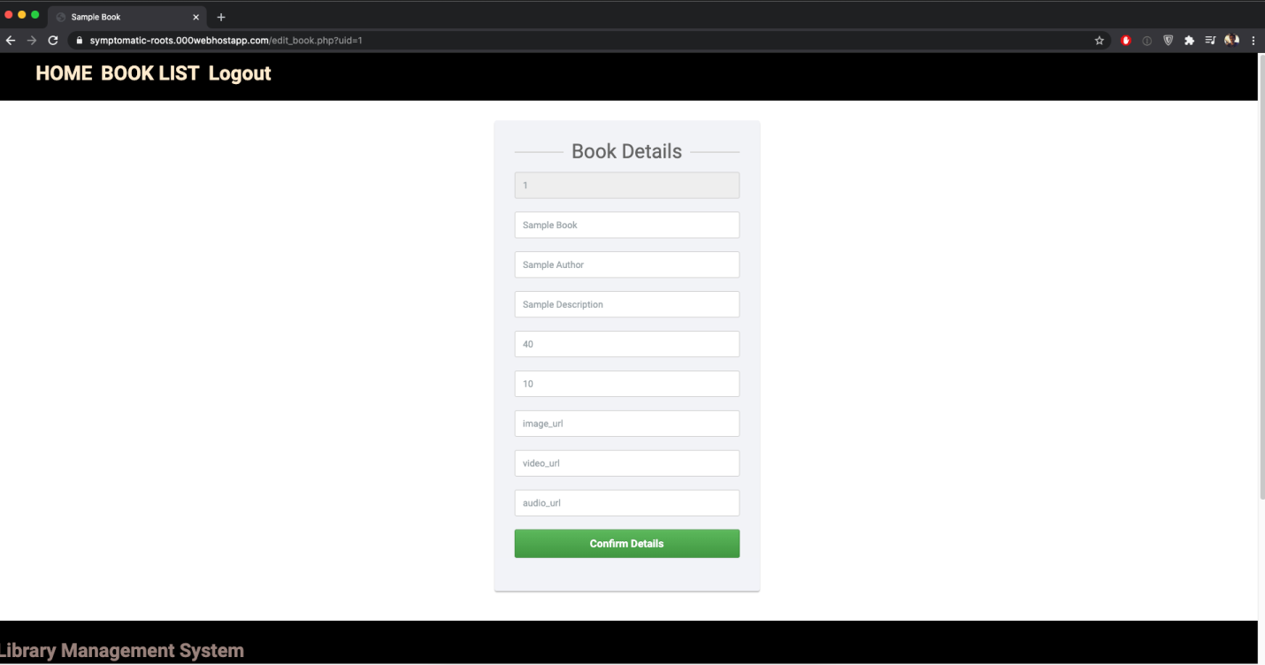

1. footer.html: The footer/ navigation bar that is present in all the designed webpages.

This page contains the names and contact details of our team members.